Guide to using Wired Relations' templates

Wired Relations' templates* can be used directly in your work with data protection and information security - but can also be used as inspiration for your own material. You can modify them as needed to make them exactly as you want them.

NOTE! There may be sections that are not relevant to all organizations.

There will be places in the text where you are prompted to insert the organization's name or other information. In these cases, it will be marked as follows: [insert organization's name].

At the bottom of each document, there will be a table that provides an overview of the document's version, the latest update, and who is responsible for the document.

Here are some additional tips for using Wired Relations' templates:
- Read the instructions carefully before you start using the templates. This will help you understand how to use them effectively.
- Customize the templates to fit your organization's needs. You can add or remove sections, change the wording, and add your own logo and branding.
- Keep your templates up to date. Data protection and information security regulations are constantly changing, so it's important to make sure your templates are always up to date.

We hope you find Wired Relations' templates helpful. If you have any questions, please don't hesitate to contact us.

Here are some links to additional resources that you may find helpful:
- The Danish Data Protection Agency: https://datatilsynet.dk/
- The Danish Centre for Cybersecurity: Center for Cybersikkerhed (cfcs.dk)

Development process
Procedure for handling development changes such as changes to systems, databases and network.
We aim for infrastructure as code, meaning as much as possible of our infrastructure will be defined by code, thus easy to review and reapply in case of emergency.
We are using [insert organization's system]. for issue and project tracking and [insert organization's system] for documentation.

Methodology
The development process is utilizing the [insert organization's methodology]. methodology.

Flow
A development task (issue) is going through various steps (status), which either ends in resolution or rejection. Anyone can raise an issue, which then will be evaluated for priority.
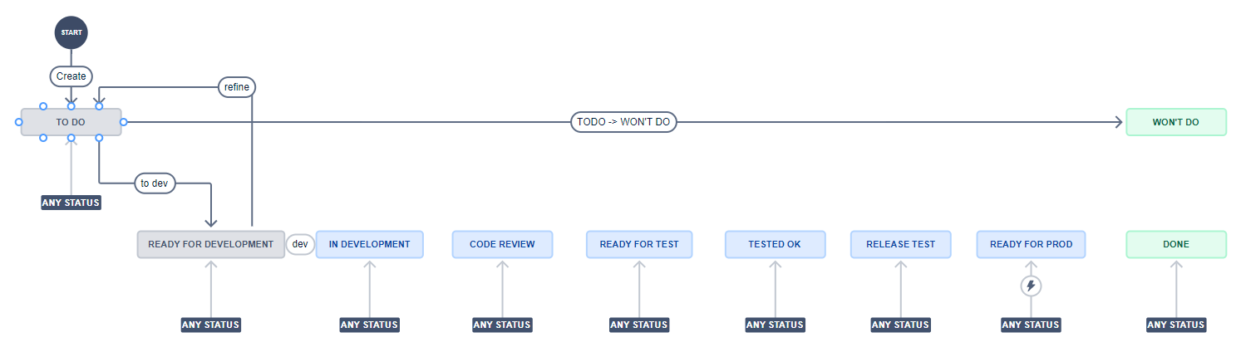

Steps
- Todo
  - Issue is created
  - PO evaluates importance and prioritizes
- Ready for development
  - Issue is ready for development
- In development
  - Developer has started development
- Code review
  - Developer has put solution for review by peers
- Ready for test
  - Implementation is ready to be tested
- Tested OK
  - Implementation is tested OK and can be planned for release
- Release test
  - Issues implementations are packaged in a release and are ready for test as a whole
- Ready for production
  - Issues in release package are tested OK and ready for production deployment
- Done (primary final state)
  - Issues are deployed to production and verified
- Won’t do (other final state)
  - PO decides the issue is not to be done - not relevant

Document Information
Document Version
Date of Issue for This Version
Responsible Person
Status

