Vejledning til anvendelse af Wired Relations’ rammeværktøj

Wired Relations’ rammeværktøj * kan anvendes direkte i jeres arbejde med databeskyttelse og informationssikkerhed– men kan selvfølgelig også anvendes som inspiration til jeres eget materiale. I kan ændre efter behov, så det bliver præcis, som I ønsker det.

OBS! Der kan være afsnit, som ikke er relevante for alle organisationer. Hvis dette er tilfældet, vil det tydeligt fremgå af teksten.

Der vil være steder i teksten, hvor der er lagt op til, at I indsætter organisationen navn eller andet. Dette vil i så fald være markeret jf. følgende: [indsæt organisationens navn].

I bunden af hvert dokument vil der fremgå en tabel, som giver et overblik over dokumentets version, seneste opdatering, samt hvem der har ansvaret for dokumentet.

Development process

Procedure for handling development changes such as changes to systems, databases and network.

We aim for infrastructure as code, meaning as much as possible of our infrastructure will be defined by code, thus easy to review and reapply in case of emergency.

We are using [indsæt organisationens system] for issue and project tracking and [indsæt organisationens system] for documentation

Methodology

The development process is utilizing the Scrum methodology

Flow

A development task (issue) is going through various steps (status), which either ends in resolution or rejection. Anyone can raise an issue, which then will be evaluated for priority.

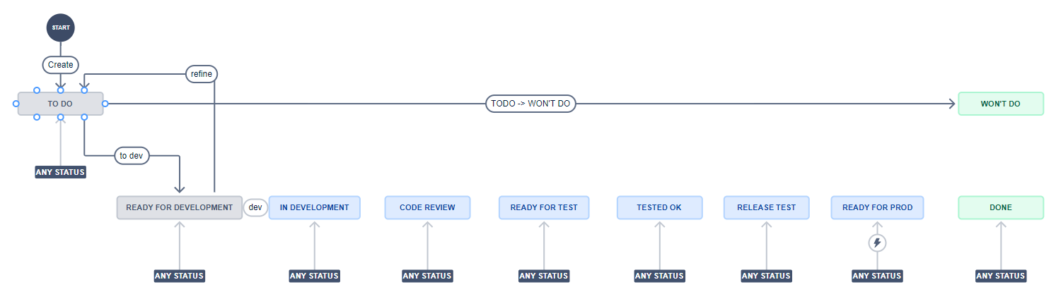

Steps

Todo

Issue is created

PO evaluates importance and prioritizes

Ready for development

Issue is ready for development

In development

Developer has started development

Code review

Developer has put solution for review by peers

Ready for test

Implementation is ready to be tested

Tested OK

Implementation is tested OK and can be planned for release

Release test

Issues implementations are packaged in a release and are ready for test as a whole

Ready for production

Issues in release package are tested OK and ready for production deployment

Done (primary final state)

Issues are deployed to production and verified

Won’t do (other final state)

PO decides the issue is not to be done - not relevant

Dokumentinformation
Dokumentversion
Dato for udgivelse af denne version
Ansvarlig
Status

